**Use Case Diagram for Library Management System.**

* **General use Case**

The aim of a use case diagram is to illustrate how various entities known as actors engage with the use case and to record the fundamental functions of a system. Here is an example of a use case diagram for a library management system, which depicts the overall processes or activities that the system can perform, based on the tasks carried out by the Admin(librarian) in a library.

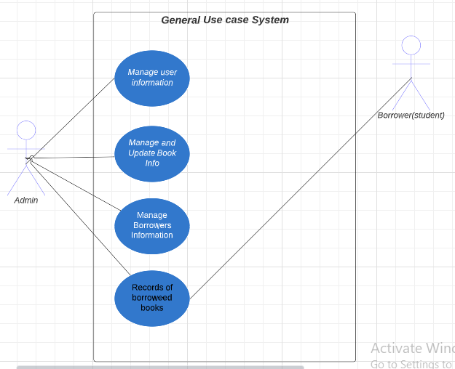

This diagram displays the use cases required to establish the essential functions of a system. These activities are interlinked to generate an anticipated output for the user.

To further elaborate on the procedures presented in this Library Management System General Use Case, continue reading.

This is the standard usage of a use case diagram. It portrays the primary constituents of the system and the transmission of data among them.

By utilizing this general use case, the developer can use it as a foundation for determining what should be taken into account when designing the library management system.

* **Manage Users Information**

This is where the admin or the main user of the system could control the users that could access the system.

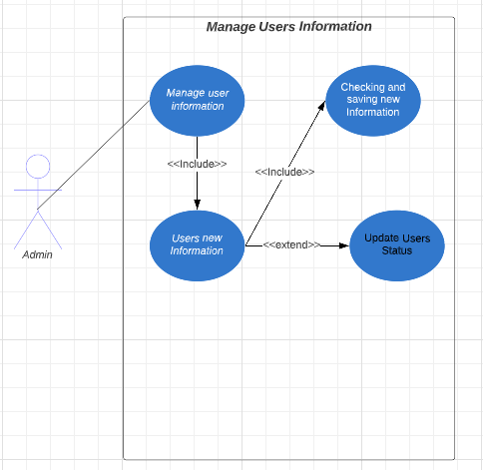

As depicted in the diagram, the Admin, acting as an actor, can input specific book details. The system subsequently checks and verifies the accuracy of the information before storing it in the database.

As a programmer, this is a crucial function that the library management system should be able to perform.

* **Update Books Information and status**

This is the process where users or the library administrator can access the information of each book present in the library. It also enables them to update the book's status, indicating whether it is available or has been borrowed by a borrower or student.

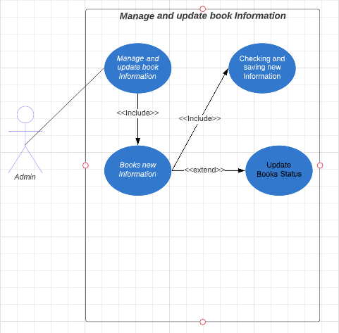

* **Manage Borrowers (Students) Information**

This process describes how the borrower's details are recorded in the system. This information serves as a reference for the admin to monitor the borrower's book transactions within the system.

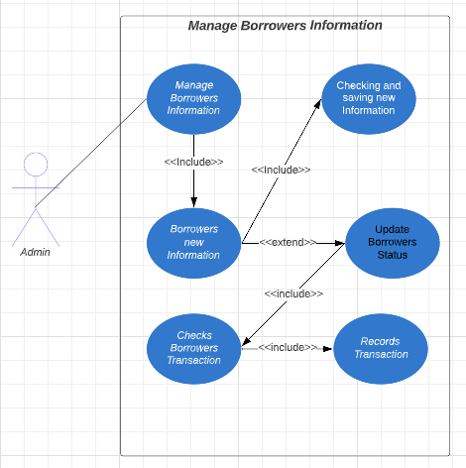

**Context Model**

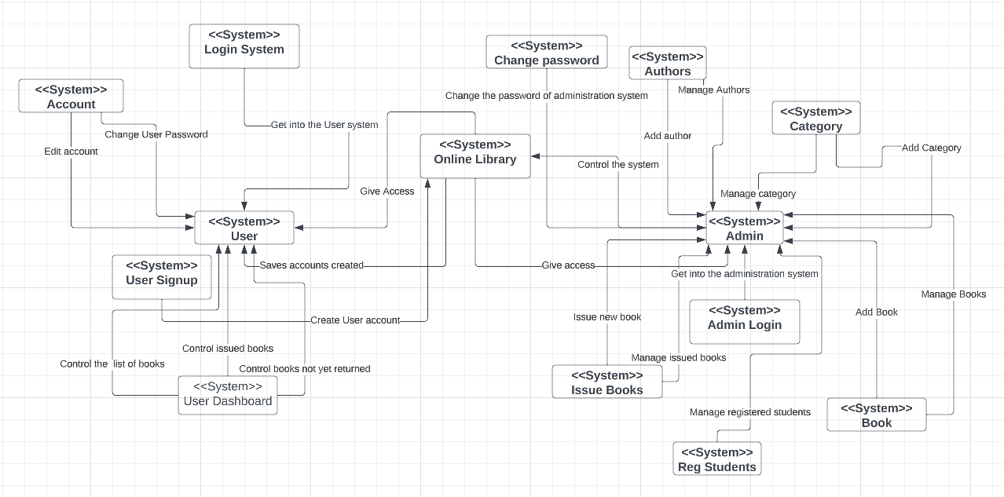

In our online library system, the context model refers to a conceptual representation of the various elements that make up the system, including users, books, resources, and the relationships between them.

The context model provides a high-level overview of the system's functionality, helping developers and stakeholders understand how the various components interact with each other. This understanding is crucial for designing and implementing the system effectively.

For example, in our application, the context model may include the following elements:

* **Users:** This includes students, faculty, and other members of the academic community who can access the library system.
* **Books/Resources:** This includes the books and other materials available in the library system, such as e-books, academic journals, and research papers.
* Catalogue: This is the searchable database of all the resources available in the library system.
* **Borrowing/Return**: This includes the process of borrowing and returning books and other materials, including due dates and late fees.
* **User Account Management:** This includes user registration, login, and account information management.
* **Reporting:** This includes generating reports on various aspects of the library system, such as book usage, user demographics, and resource availability.
* **Admin:** This includes the administration staff of the library which has a duty to control all the events of the library.

The context model provides a conceptual framework for understanding how all these components interact with each other, allowing developers to design a system that meets the needs of its users effectively.